**WordPress User Manual**

**9346B**

**Group 4**

**MEMBERS:**

Andrada, Jason

Guiab, John Carlo

Patricio, Jan Ronald

Pis-o, Henrod

Viloria,Brendon Bruce

De Vera, Melody Riza

Lonogan, Mehanie Jiral

Rocafort, Jam Spica

Willy, Kim

Table of Contents

**LOGIN TO THE SITE AS WordPress ADMIN** 1

**CUSTOMIZE WEBSITE** 2

THEMES 2

CUSTOMIZER 3

**EDIT CONTENT AND DESIGN WITH EMELENTOR** 5

DASHBOARD CONTENT EDITING 5

SECTION AND ELEMENT 5

ELEMENTOR CONTENT EDITING 6

TEMPLATES 6

**POST TABLE WITH SEACRCH & SORT PLUGIN** 7

USING POSTS FOR CONTENT 7

ADDING USERS TO USE AS AUTHORS 7

# **LOGIN TO THE SITE AS WordPress ADMIN**

Login to the website by adding “/wp-admin” to the end of the websites domain name.

[www.slulibrary.com/wp-admin](http://www.slulibrary.com/wp-admin)

username: webtech

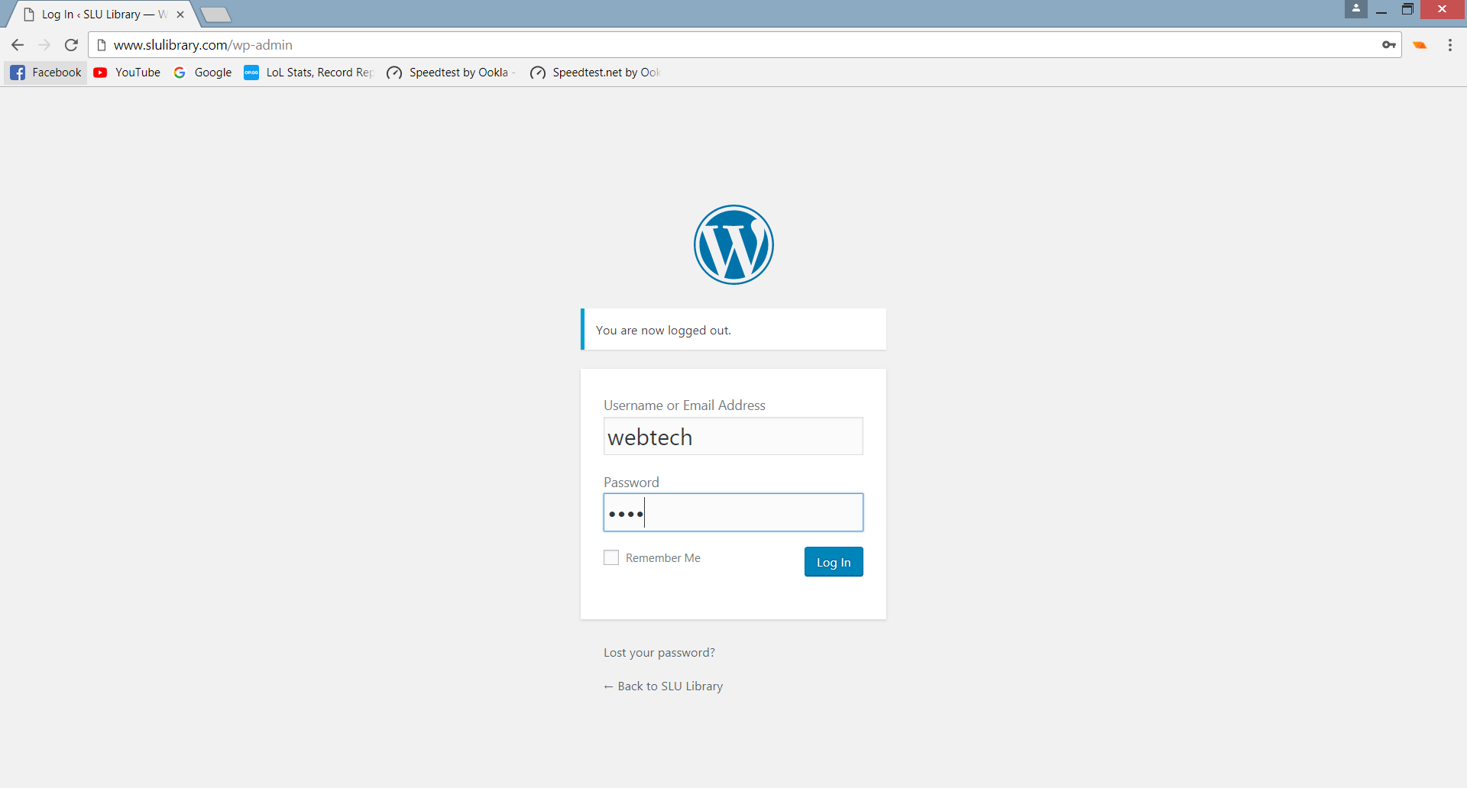 password: 2018

After logging in, you will be directed to the dashboard. You will see the admin bar both in the dashboard and on your website when you are logged in. The dashboard is where you can create/edit posts, pages, users, add media files, plugins, change appearance, settings and other administrative changes.

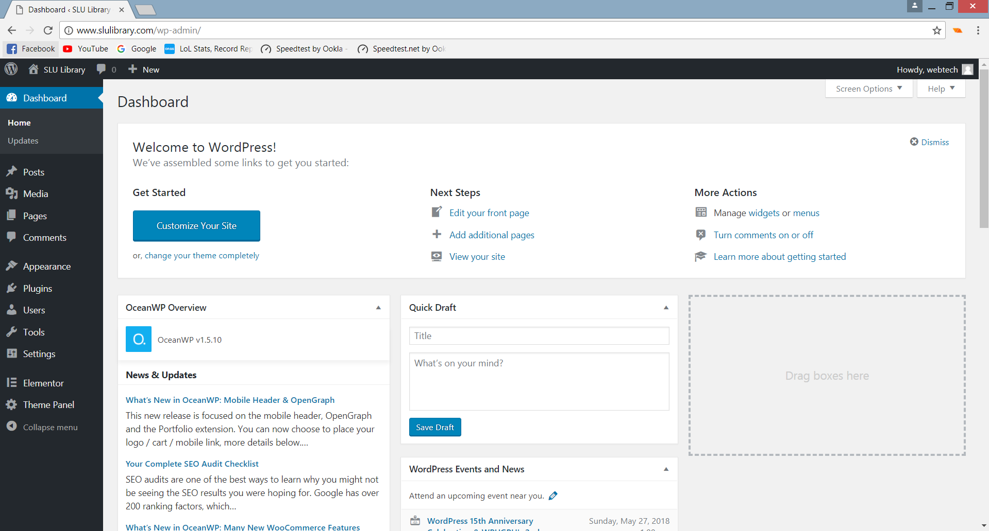

# **CUSTOMIZE WEBSITE**

## THEMES

You can customize how your website look by using downloaded themes you can use your own theme.

Choose Appearance on the left sidebar then click Themes.

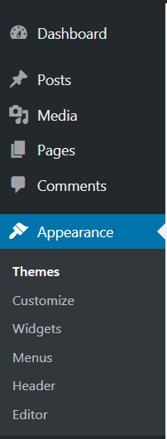

You can select from the downloaded themes or download new themes by clicking the ADD NEW button.

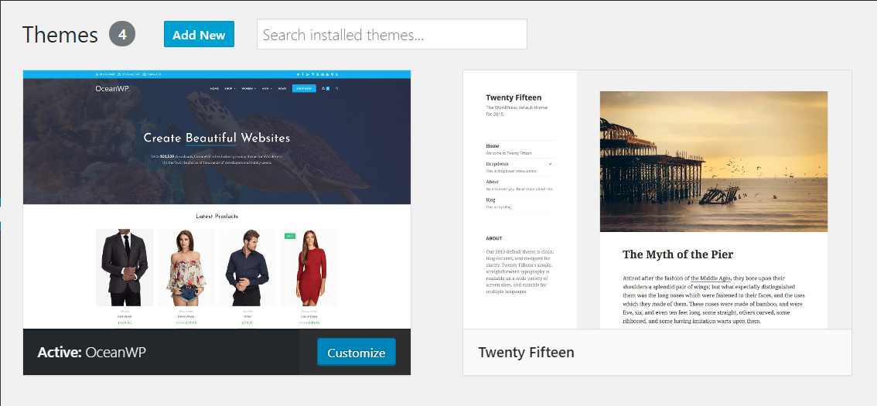

You can click Live Preview to view how the theme looks or Active to use the theme or Delete to delete the theme from the downloaded list of themes.

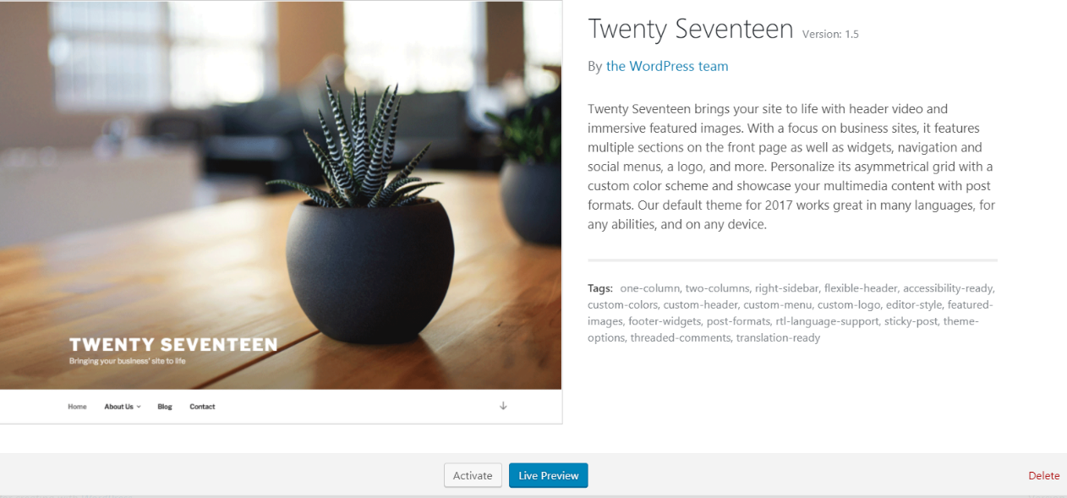

## CUSTOMIZER

You can customize the appearance of your website by choosing and editing the settings and options of the available sections on the customizer side bar.

Choose customize from the admin bar.



Then select the sections that you want to change. e.g You can edit your Site Identity like Site Title, Tagline, add logo, etc.

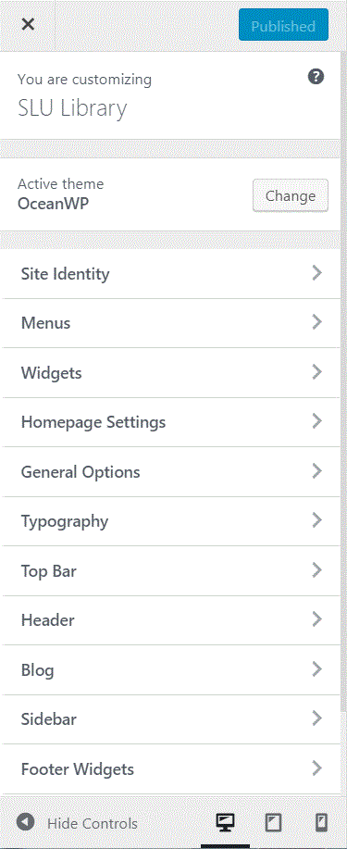

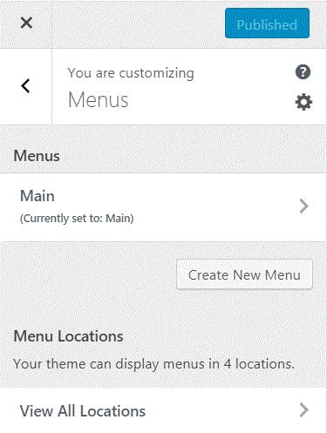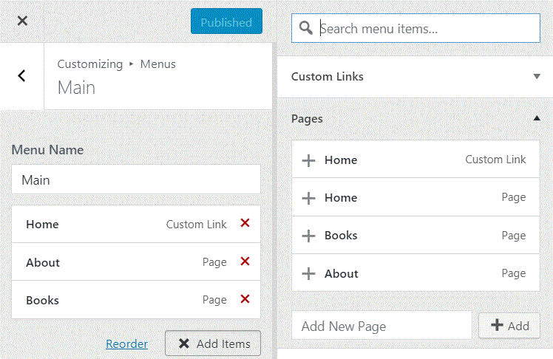To add pages to the menu, click Menus then click Create New Menu or Select existing Menu. Then click Add Items then add the pages that you want to add from the created pages on the dashboard.

To create a page, go to dash board, click pages, click Add New page then fill up the page information.

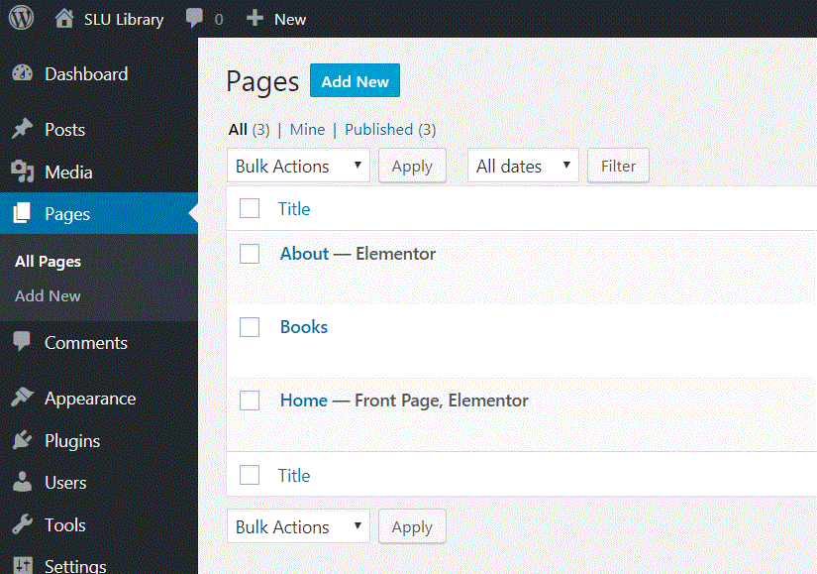

# **EDIT CONTENT AND DESIGN WITH EMELENTOR**

You can edit page contents on the Page menu on the dashboard or use Elementor to add contents. Elementor is a page builder that allows designing a page with drag & drop method. You can add header, text editor and other elements for the contents of your website.

## DASHBOARD CONTENT EDITING

Go to Page on the dashboard, click edit to edit the page that you want then add the content on the text field.

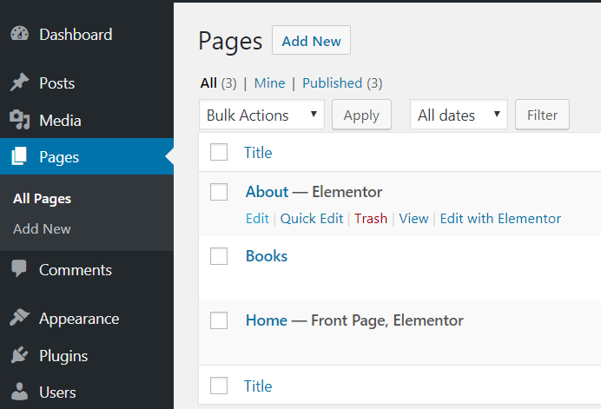

## SECTION AND ELEMENT

Go to Page on the dashboard, click edit to edit just like before then choose Edit with Elementor. You can add sections to your webpage by clicking ADD NEW SECTION the drag the elements to your web page.

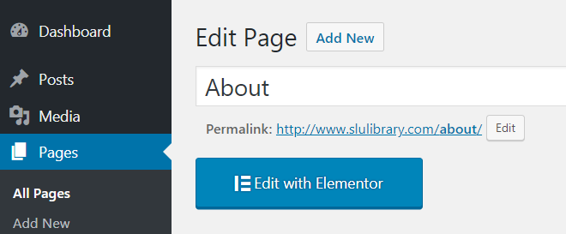

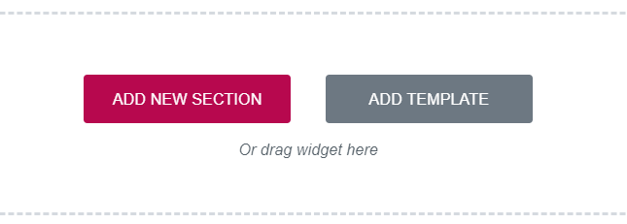

## ELEMENTOR CONTENT EDITING

There are elements that you can use for the contents of your website. Choose the element that you are using for the content then edit the content.

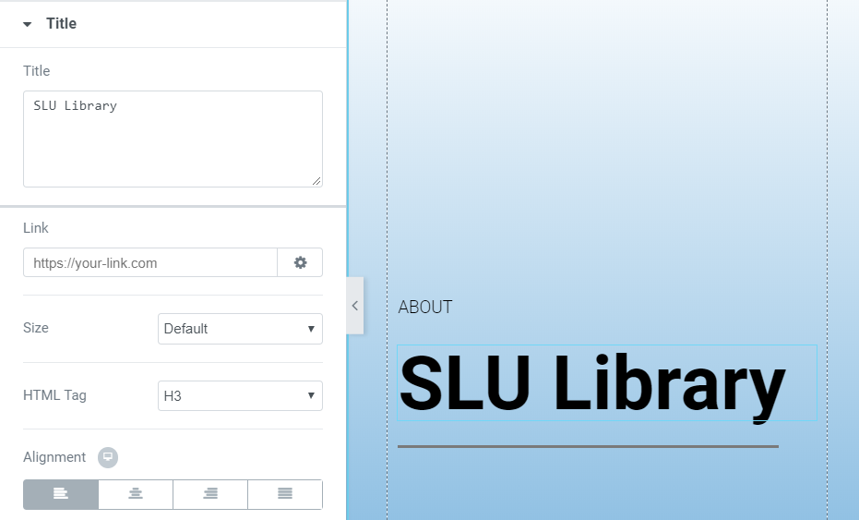

## TEMPLATES

Click ADD TEMPLATE use available templates or download templates from the internet. You can choose between Block which are only small section or a Page for the template of the whole page or My Template if there is.

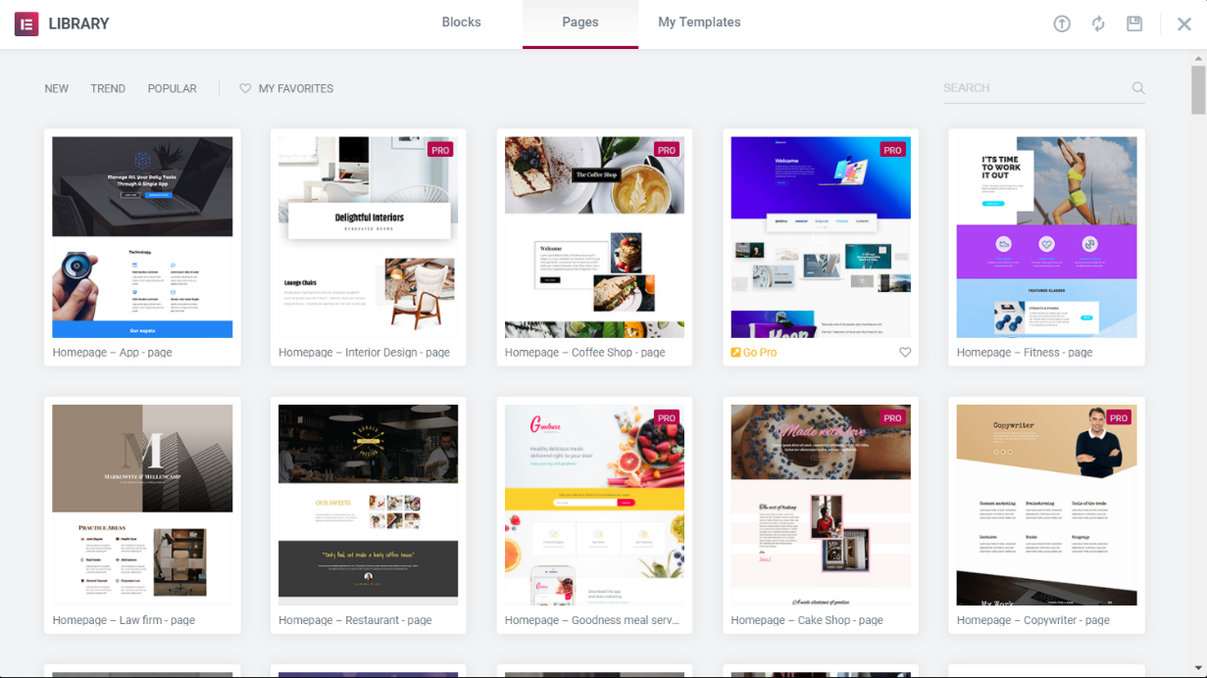

# **POST TABLE WITH SEACRCH & SORT PLUGIN**

This plugin is used to list all of your site’s posts in a searchable and sortable data table. The Posts can be used for the books’ information.

## USING POSTS FOR CONTENT

Click Posts on the Dashboard, Add New then fill up the Content, Category and Author to add a new Post.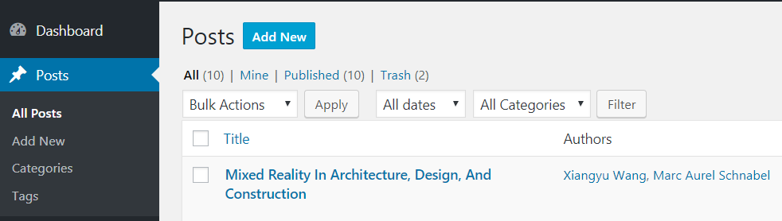

## ADDING USERS TO USE AS AUTHORS

To add authors on the available author. Click Users on the Dashboard Add New the fill up the necessary information then set the user’s role to Author.

